**1)Consider a scenario I have two un related objects “A” and “B”.Now I want to create a Master Detail relation between these objects how do I do this?**

**Answer:-**

You cannot create a new Master-Detail relationship on an existing custom object if records already exist.

You must first create a Lookup relationship, populate the lookup field with data in all records, and then change the relationship type to Master-Detail.

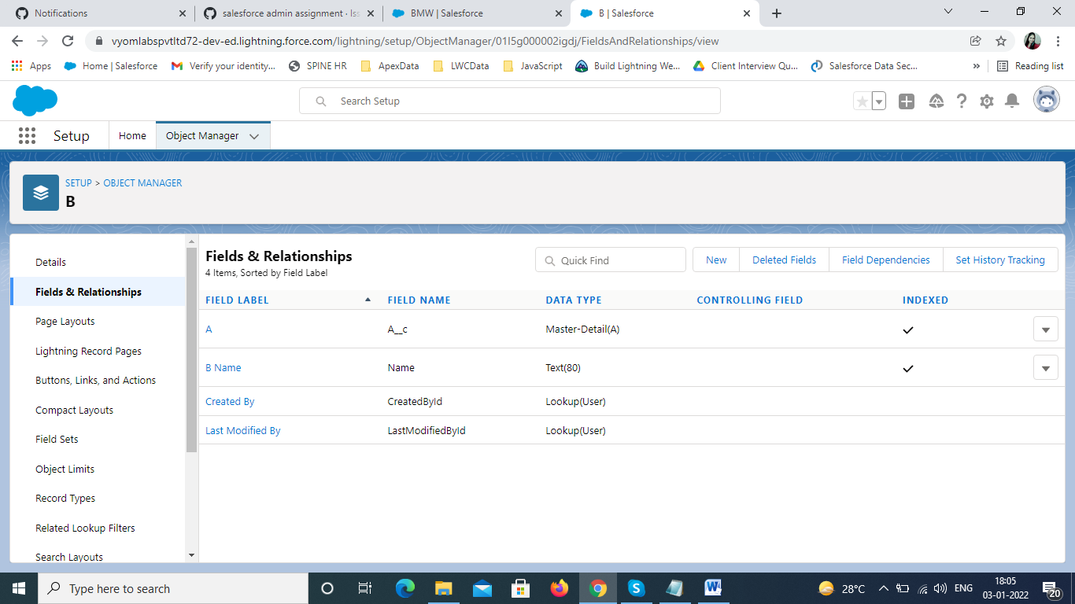

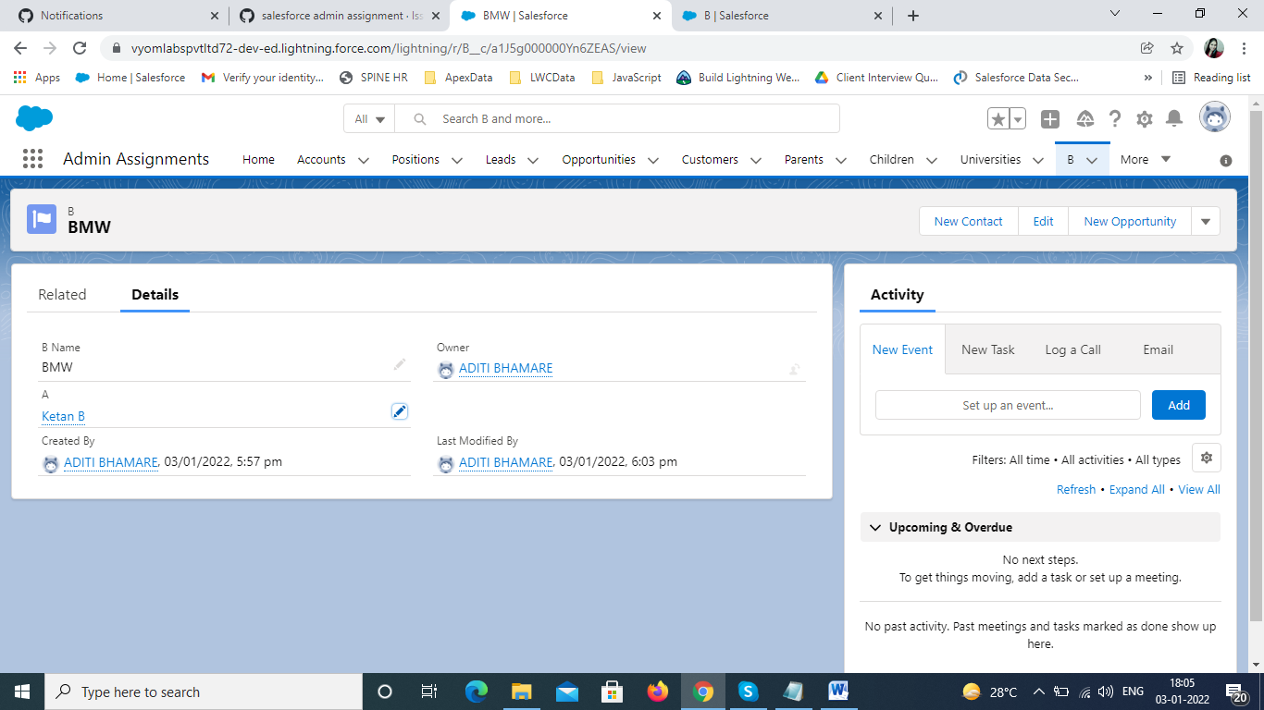

**2)create University(master) and department(details) objects with fields and records and once university is no existence then department records should also be not in existence use master details relationship to implement?**

**Answer:-**

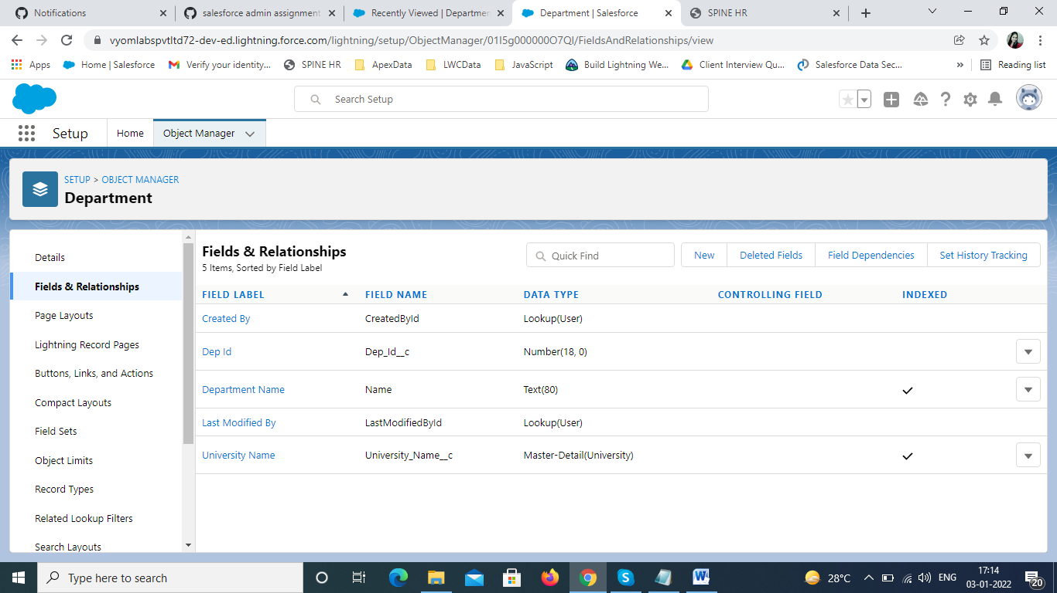

**3)create company and Employee objects with fields and records where in case if company get deleted even employee records should be existence use look up and implement it.**

Answer:-

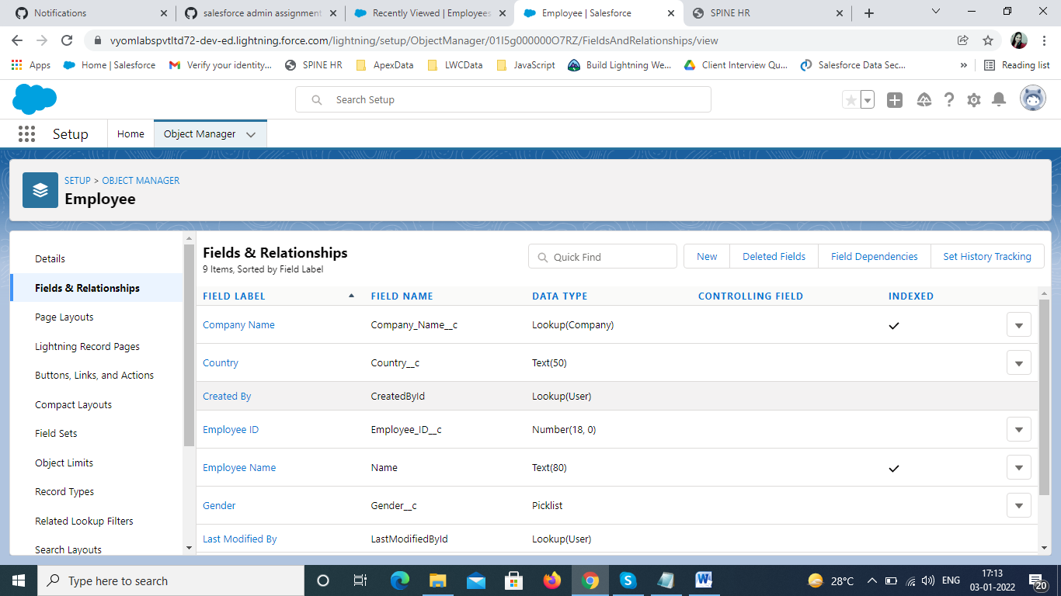

**5)create Student object with four subject marks and calculate result .**

**Answer:-**

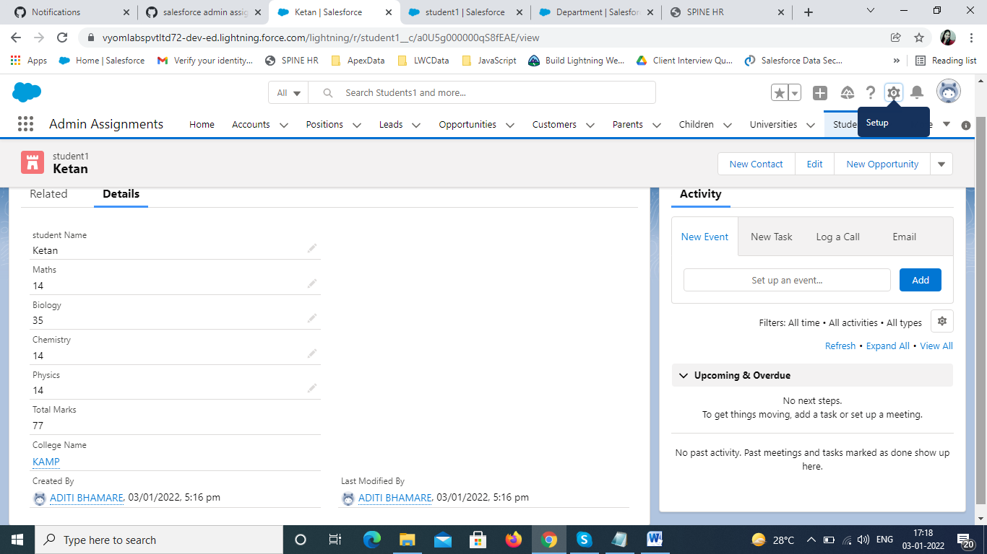

**6) create professor and Student objects and implement many Professor have many students (use Juntion object to implement many-to-many relationship)**

**Securing and Sharing Data**

Answer:-

Professor object

Student2 object

College website junction object

